
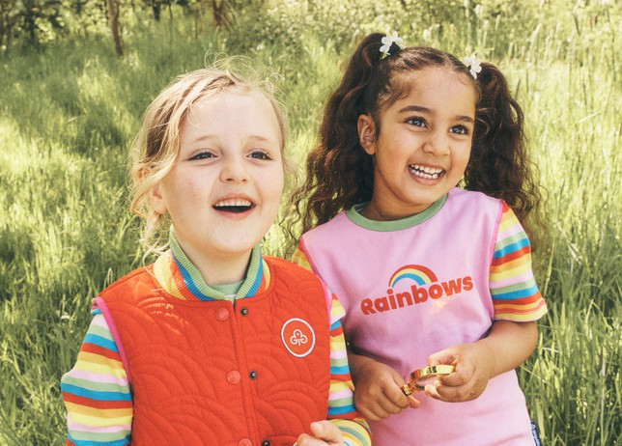

Rainbows welcomes girls to come together to laugh, learn and have fun in a creative, supportive space.

Girls play, learn and have tons of fun for ages 4 to 7
Location: type unit meeting place location here
Day: type unit meeting day here
Time: type unit meeting start and finish time here
Contact: share contact email address/phone number for the unit here


Join a local Rainbows group: girlguiding.org.uk/joinus


Girls play, learn and have tons of fun
for ages 4 to 7
Rainbows welcomes girls to come together to laugh, learn and have fun in a creative, supportive space.
Location: type unit meeting place location here
Day: type unit meeting day here
Time: type unit meeting start and finish time here
Contact: share contact email address/phone number for the unit here

Join a local Rainbows group: girlguiding.org.uk/joinus

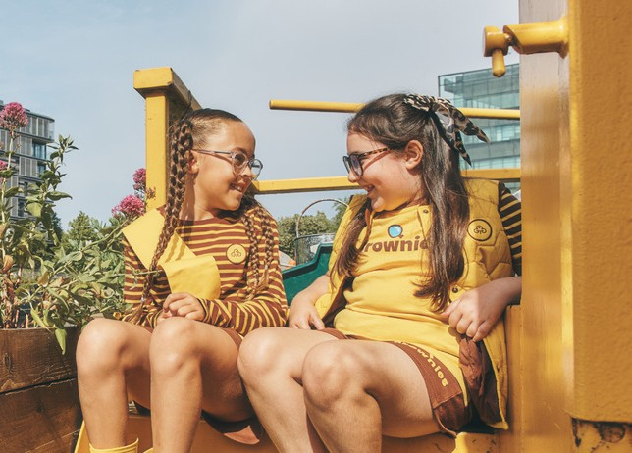




At Brownies, girls roll up their sleeves and get stuck in: growing vegetables, getting crafty, inventing games, earning dance badges and finding their voice.
Girls have non-stop fun, learning and adventure for ages 7 to 10
Location: type unit meeting place location here
Day: type unit meeting day here
Time: type unit meeting start and finish time here
Contact: share contact email address/phone number for the unit here

Join a local Brownies group: girlguiding.org.uk/joinus


Girls have non-stop fun, learning and adventure for ages 7 to 10
At Brownies, girls roll up their sleeves and get stuck in: growing vegetables, getting crafty, inventing games, earning dance badges and finding their voice.
Location: type unit meeting place location here
Day: type unit meeting day here
Time: type unit meeting start and finish time here
Contact: share contact email address/phone number for the unit here

Join a local Brownies group: girlguiding.org.uk/joinus

Girls laugh, learn and expand their horizons for ages 10 to 14

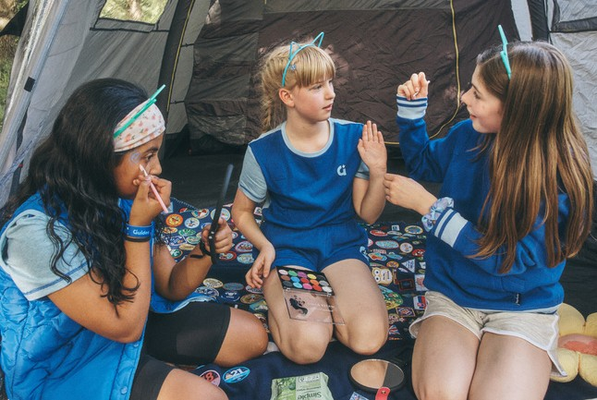

At Guides, girls can have fun in a supportive space.

From photography and vlogging to campfire cooking and codebreaking, she’ll explore what she loves, make friends and build confidence along the way.
Location: type unit meeting place location here
Day: type unit meeting day here
Time: type unit meeting start and finish time here
Contact: share contact email address/phone number for the unit here

Join a local Guides group: girlguiding.org.uk/joinus

Girls laugh, learn and expand their horizons for ages 10 to 14


At Guides, girls can have fun in a supportive space. From photography and vlogging to campfire cooking and codebreaking, she’ll explore what she loves, make friends and build confidence along the way.
Location: type unit meeting place location here
Day: type unit meeting day here
Time: type unit meeting start and finish time here
Contact: share contact email address/phone number for the unit here

Join a local Guides group: girlguiding.org.uk/joinus

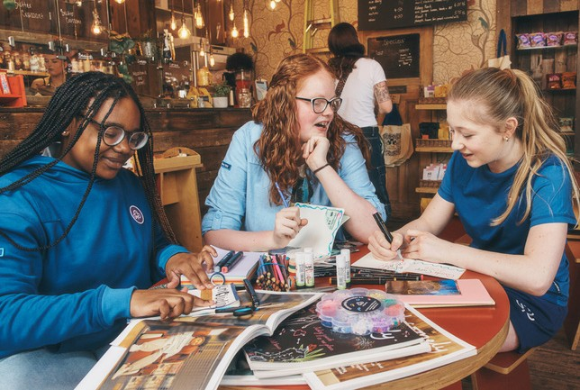

Rangers is a relaxed space for you to hang out with friends and be yourself. From celebrating fandoms and decorating wellies to planning micro-adventures and travelling abroad. Shape your own journey.
Location: type unit meeting place location here
Day: type unit meeting day here
Time: type unit meeting start and finish time here
Contact: share contact email address/phone number for the unit here

Girls have fun, hang out, learn more and give back for ages 14 to 18

Join a local Rangers group: girlguiding.org.uk/joinus


Girls have fun, hang out, learn more and give back for ages 14 to 18
Rangers is a relaxed space for you to hangout
with friends and be yourself. From celebrating fandoms and
decorating wellies to planning micro-adventures and travelling abroad. Shape your own journey.
Location: type unit meeting place location here
Day: type unit meeting day here
Time: type unit meeting start and finish time here
Contact: share contact email address/phone number for the unit here

Join a local Rangers group: girlguiding.org.uk/joinus

